Pitot Tube
# Source: AI Source: Provided by: [Data Path: Persons Table -> ID Column: 1, Name_En Column: Motasem Essam] -> From: [ChatGPT] on [7/17/2026]
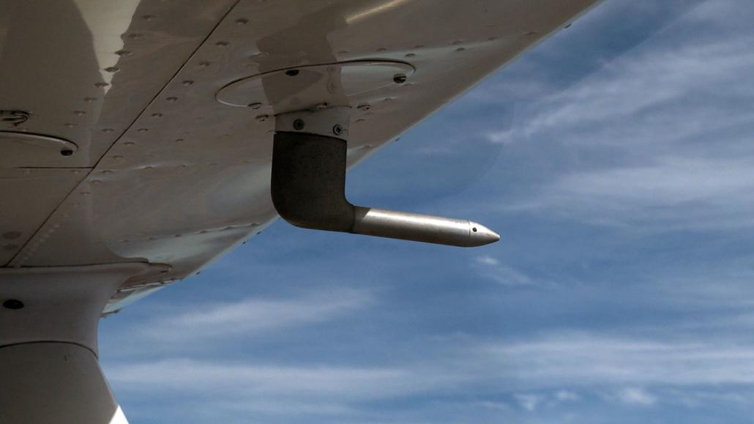
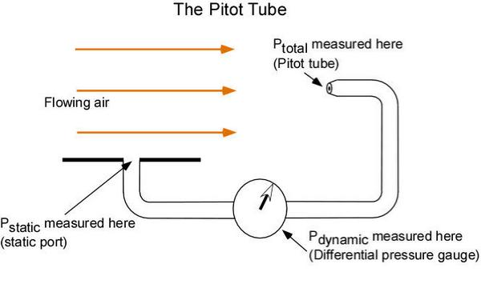
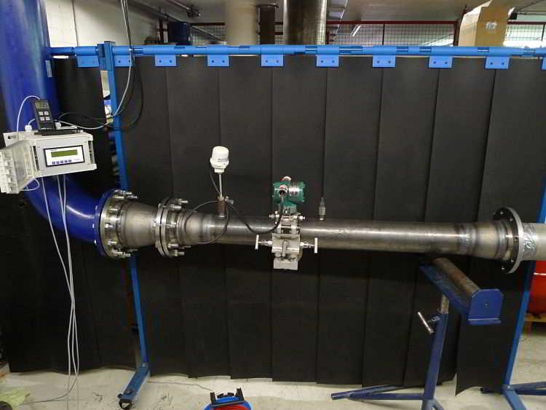
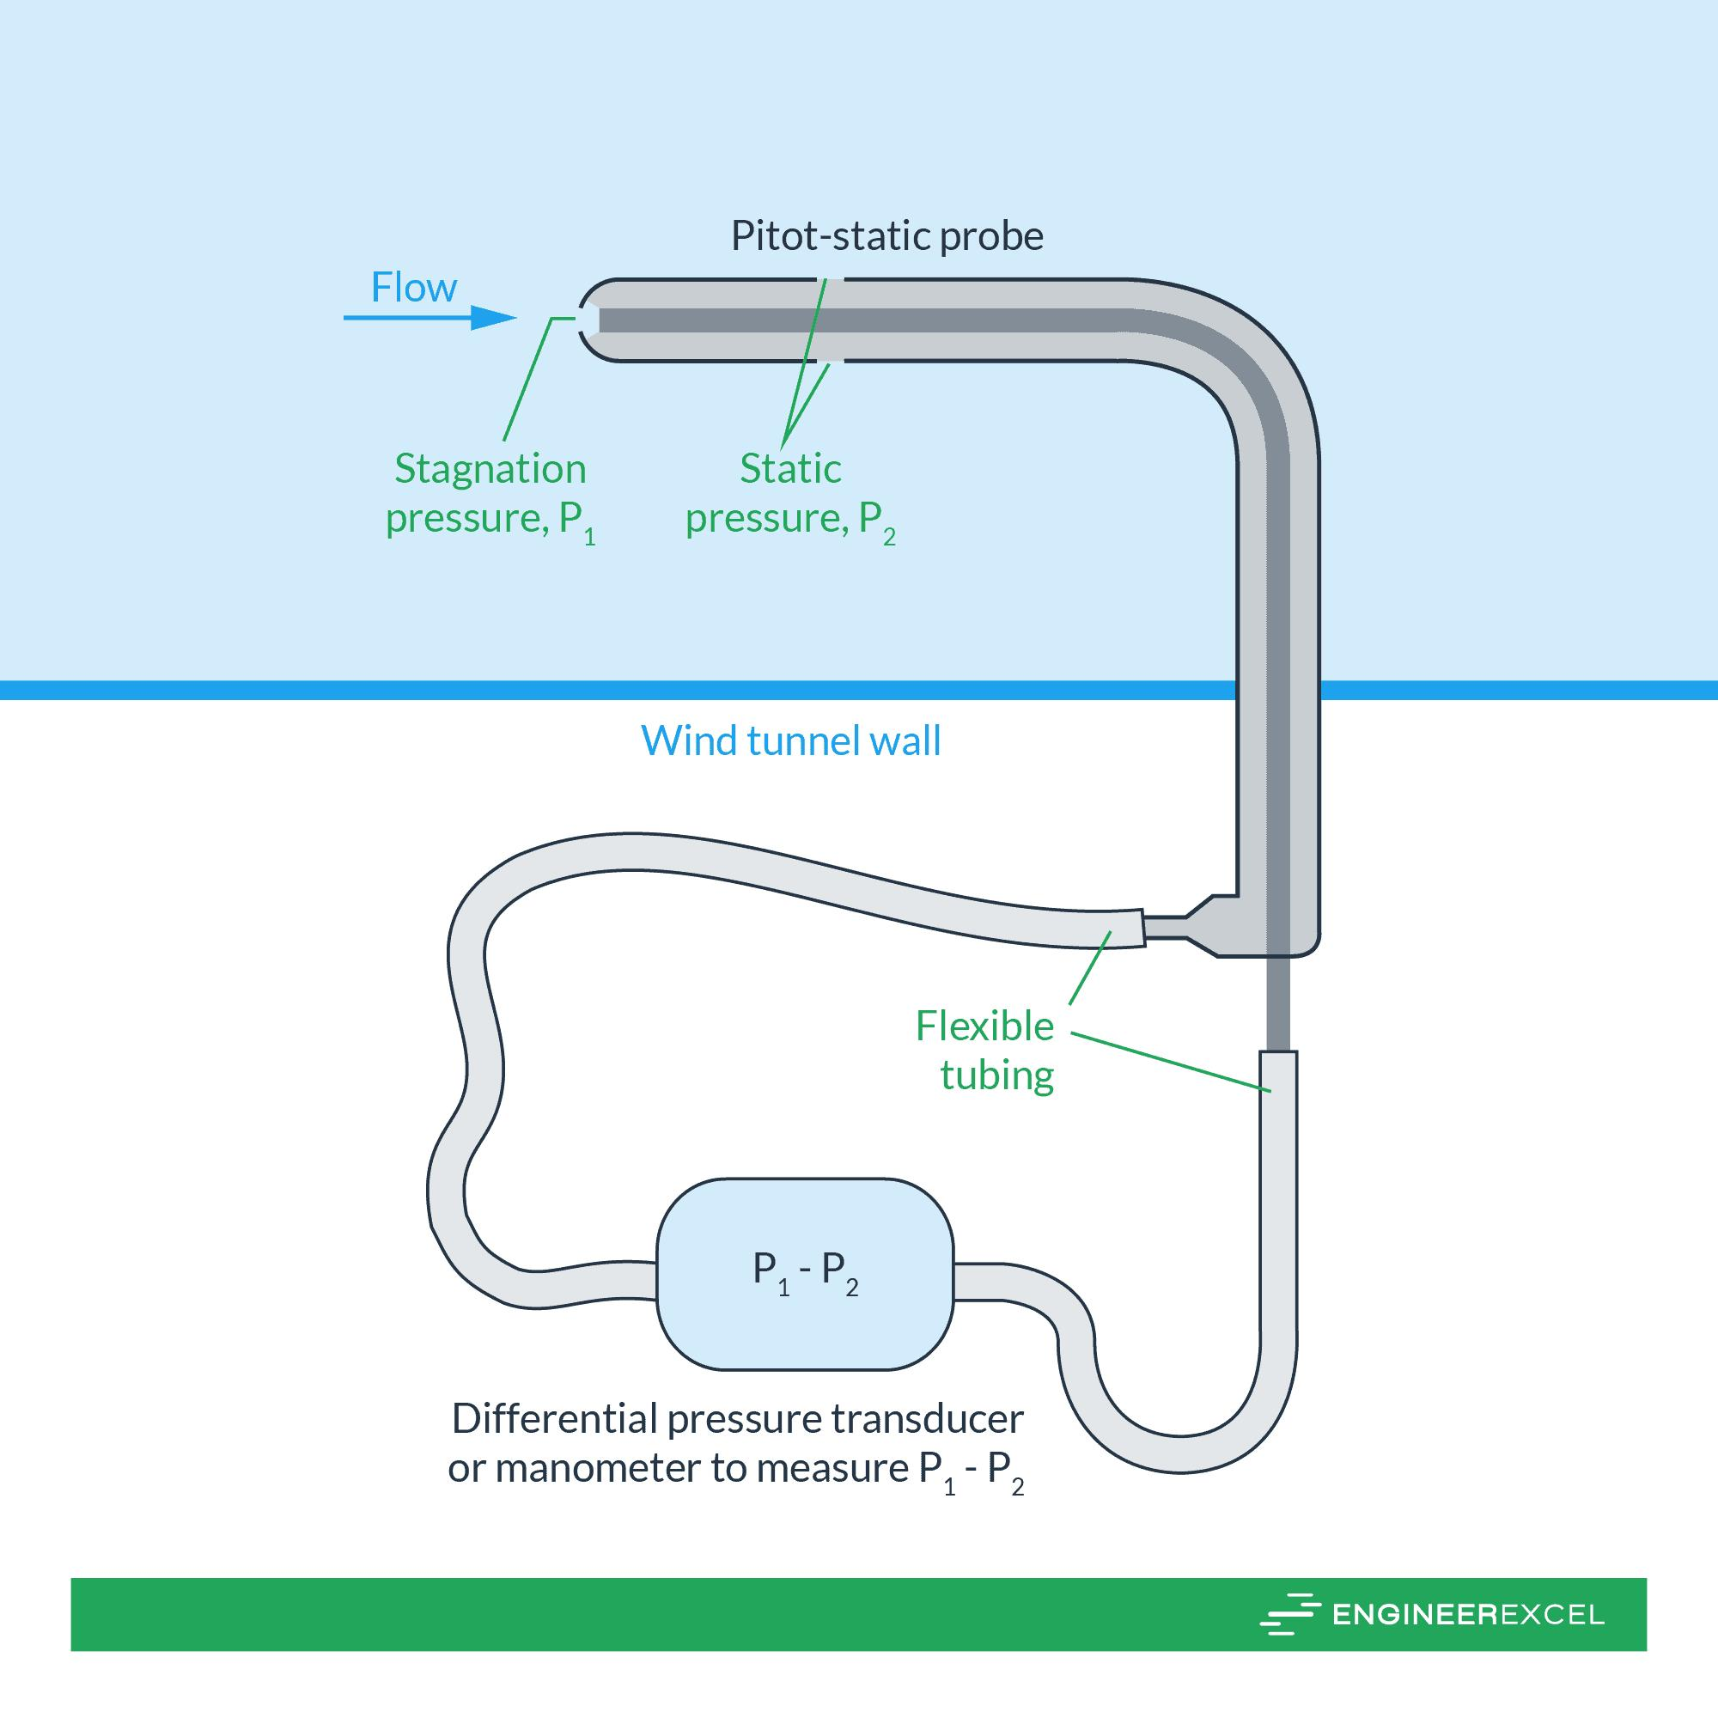
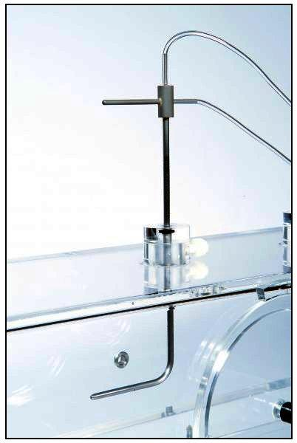
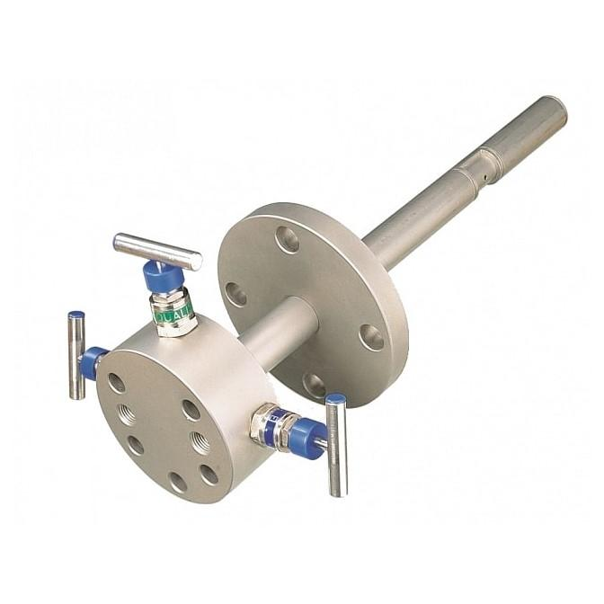
A Pitot Tube is a fluid-flow measuring instrument used to determine the speed (velocity) of a moving fluid, such as air or liquid, by measuring the difference between stagnation pressure and static pressure. It is one of the most widely used instruments for measuring airspeed in aircraft and flow velocity in pipes and ducts.

Definition
# Source: AI Source: Provided by: [Data Path: Persons Table -> ID Column: 1, Name_En Column: Motasem Essam] -> From: [ChatGPT] on [7/17/2026]
A Pitot Tube is a speed-measuring instrument that determines the velocity of a moving fluid by comparing its stagnation (total) pressure with its static pressure.

Purpose
# Source: AI Source: Provided by: [Data Path: Persons Table -> ID Column: 1, Name_En Column: Motasem Essam] -> From: [ChatGPT] on [7/17/2026]
A Pitot tube is used to:
- Measure airspeed.
- Measure fluid flow velocity.
- Monitor airflow in ducts.
- Measure water flow in pipelines.
- Support aerodynamic testing.

Principle of Operation
# Source: AI Source: Provided by: [Data Path: Persons Table -> ID Column: 1, Name_En Column: Motasem Essam] -> From: [ChatGPT] on [7/17/2026]
A Pitot tube works according to Bernoulli's Principle.
The instrument measures:
- Stagnation (Total) Pressure – pressure when the fluid is brought to rest.
- Static Pressure – pressure of the moving fluid.
The pressure difference is converted into fluid velocity.

Main Components
# Source: AI Source: Provided by: [Data Path: Persons Table -> ID Column: 1, Name_En Column: Motasem Essam] -> From: [ChatGPT] on [7/17/2026]

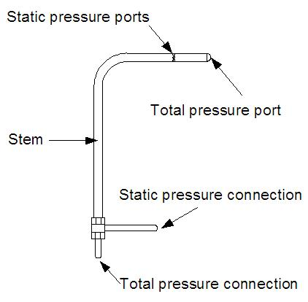
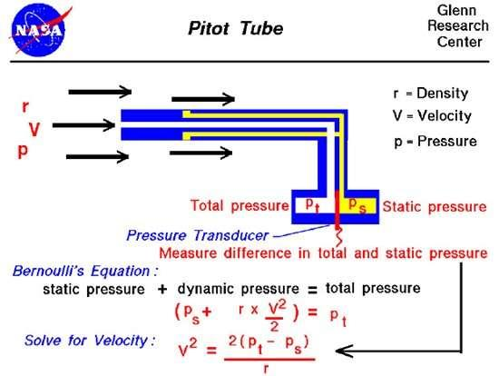
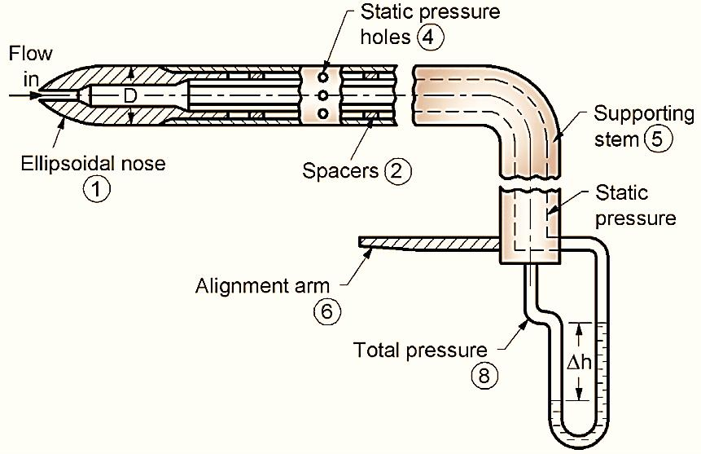
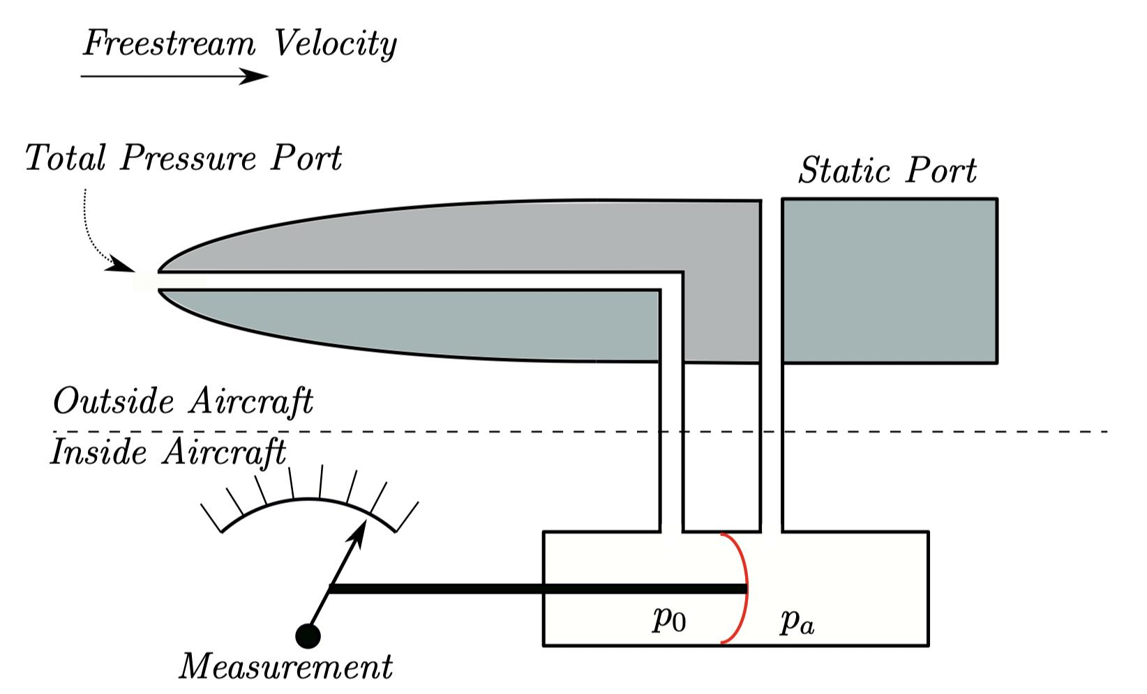
A typical Pitot tube consists of:
- Total pressure opening (Pitot opening)
- Static pressure ports
- Pressure tubes
- Differential pressure sensor or manometer
- Probe body

Types of Pitot Tubes

1. Standard Pitot Tube
# Source: AI Source: Provided by: [Data Path: Persons Table -> ID Column: 1, Name_En Column: Motasem Essam] -> From: [ChatGPT] on [7/17/2026]
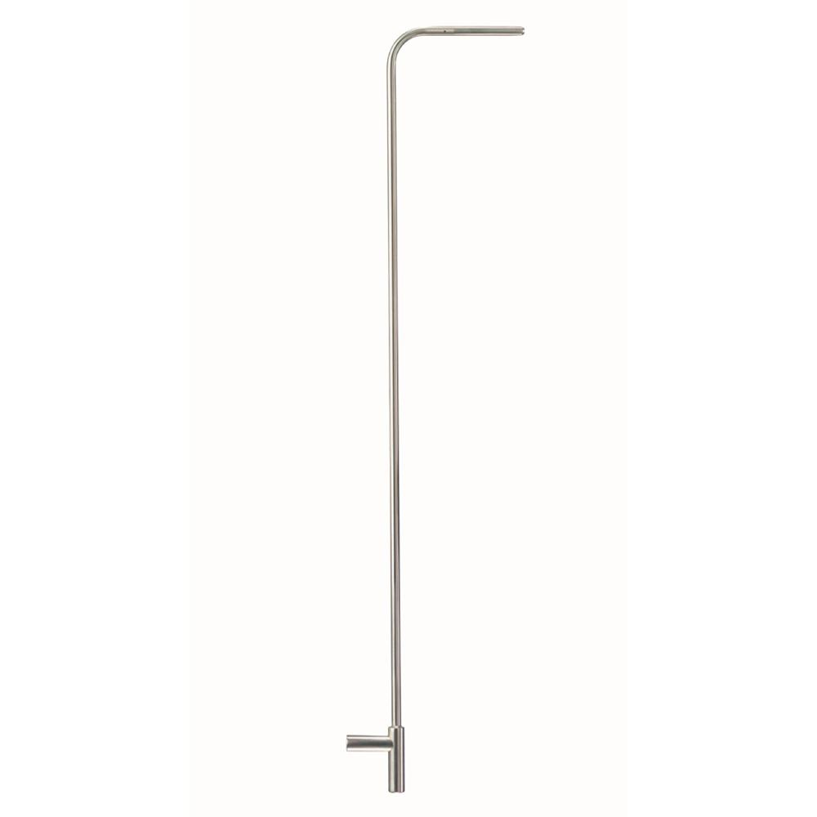
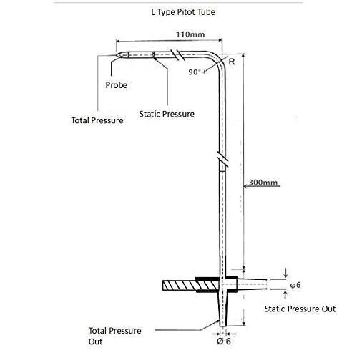
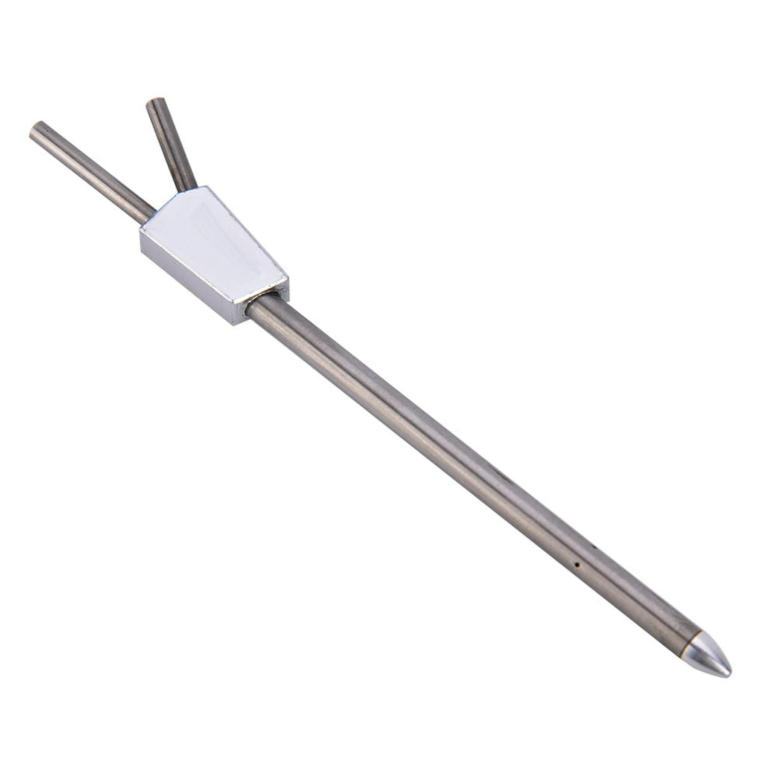
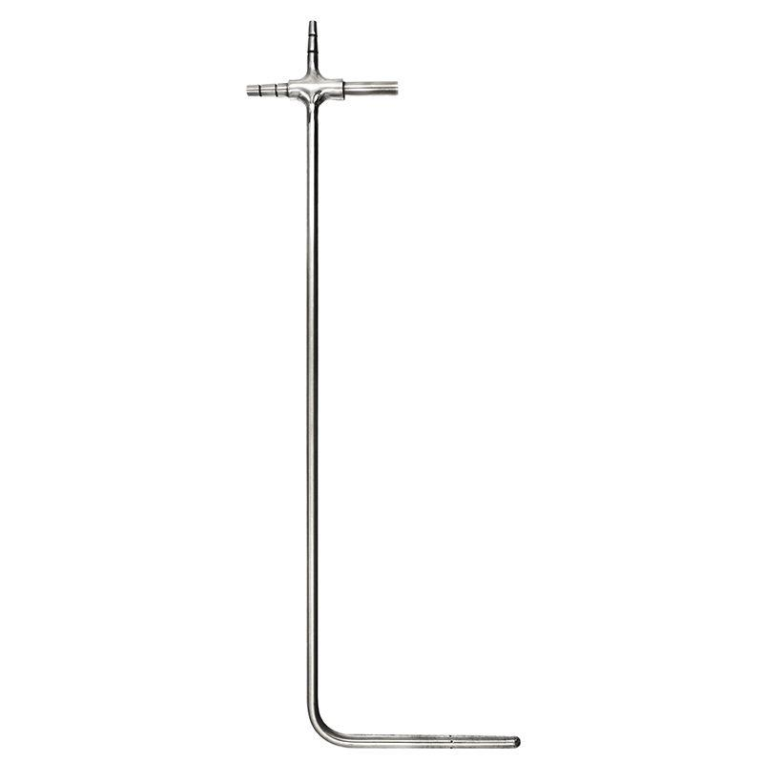
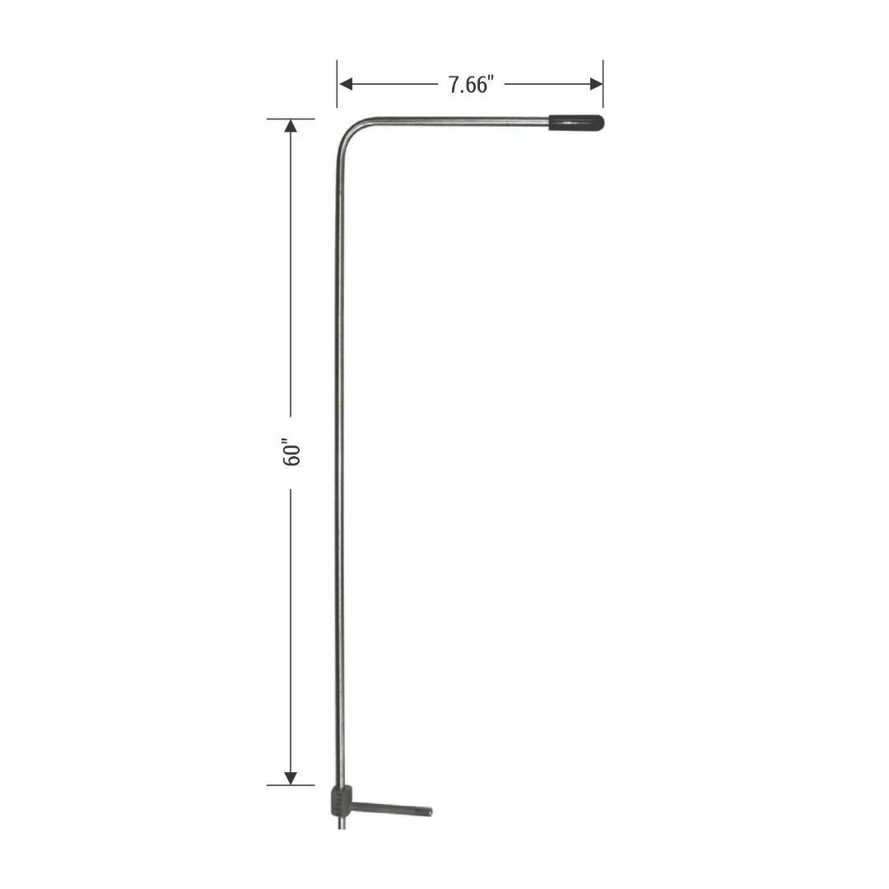
Description
Measures only the stagnation pressure and requires a separate static pressure source.
Applications
- Wind tunnels
- Laboratory experiments
- Fluid mechanics

2. Pitot-Static Tube
# Source: AI Source: Provided by: [Data Path: Persons Table -> ID Column: 1, Name_En Column: Motasem Essam] -> From: [ChatGPT] on [7/17/2026]
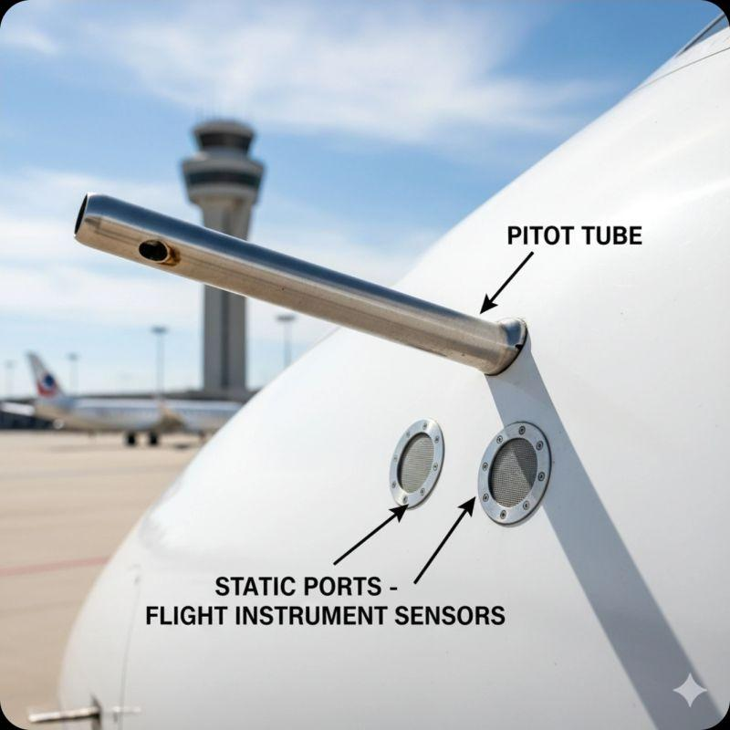


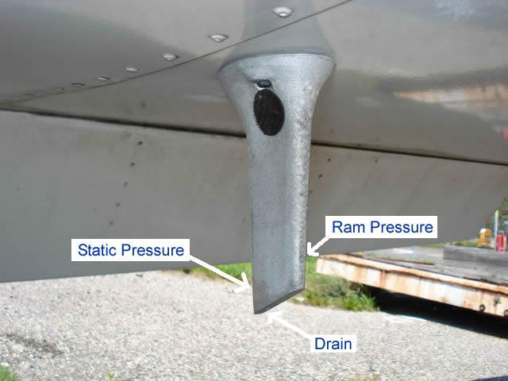
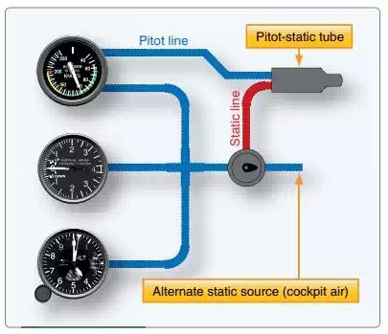
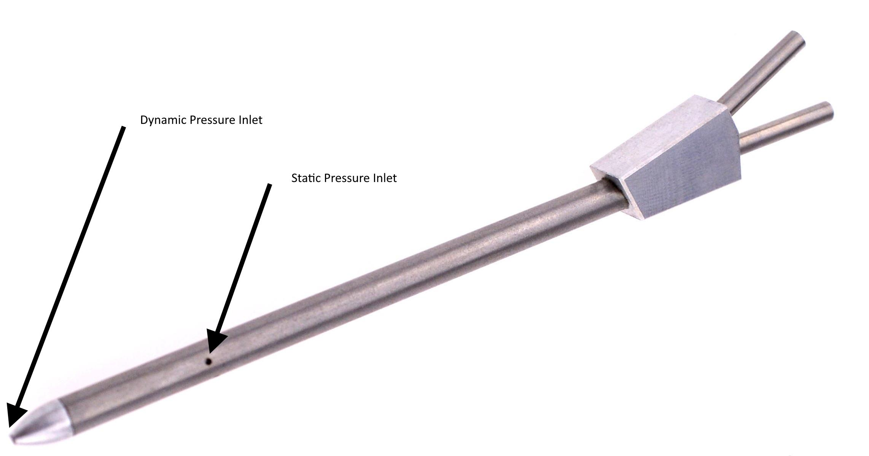
Description
Combines both total-pressure and static-pressure ports in a single probe.
Applications
- Aircraft airspeed systems
- Aviation testing
- Aerodynamics

3. Averaging Pitot Tube (Annubar)
# Source: AI Source: Provided by: [Data Path: Persons Table -> ID Column: 1, Name_En Column: Motasem Essam] -> From: [ChatGPT] on [7/17/2026]
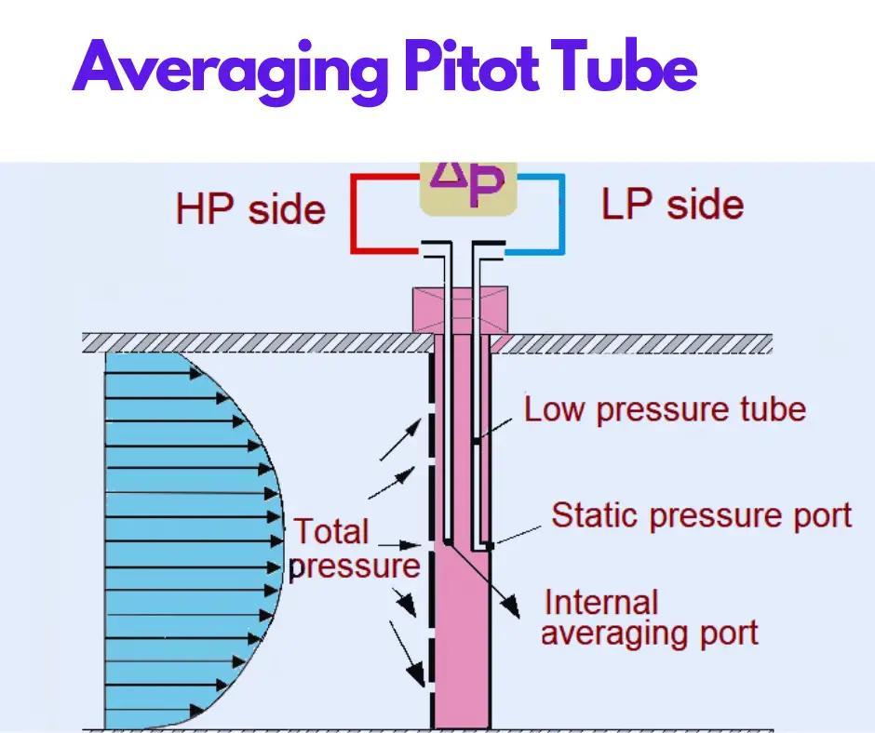
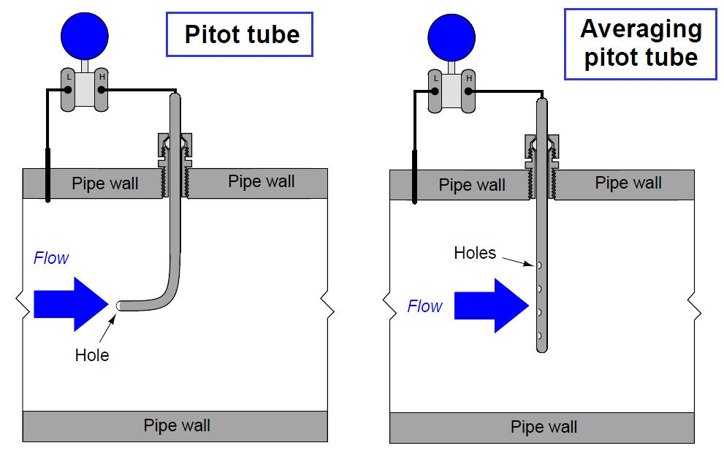
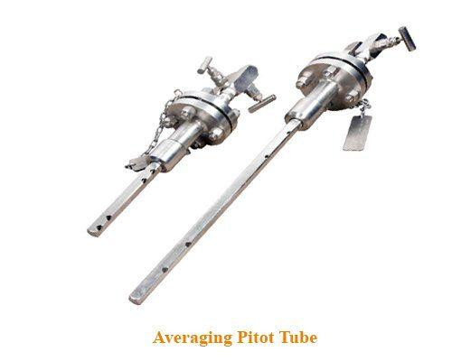
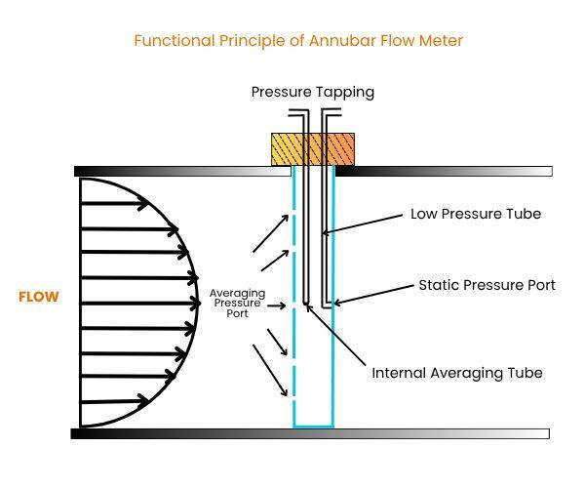
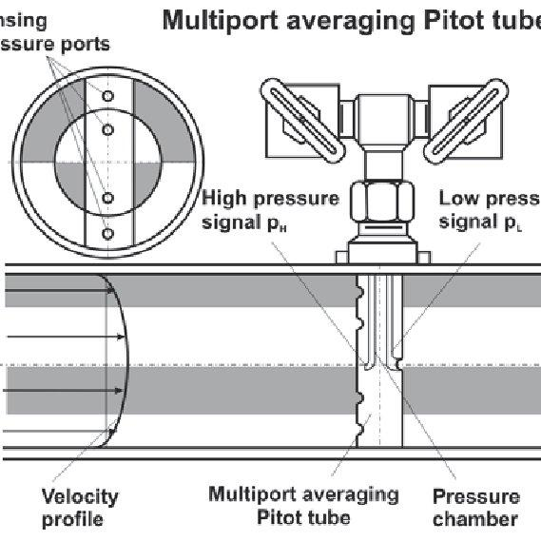
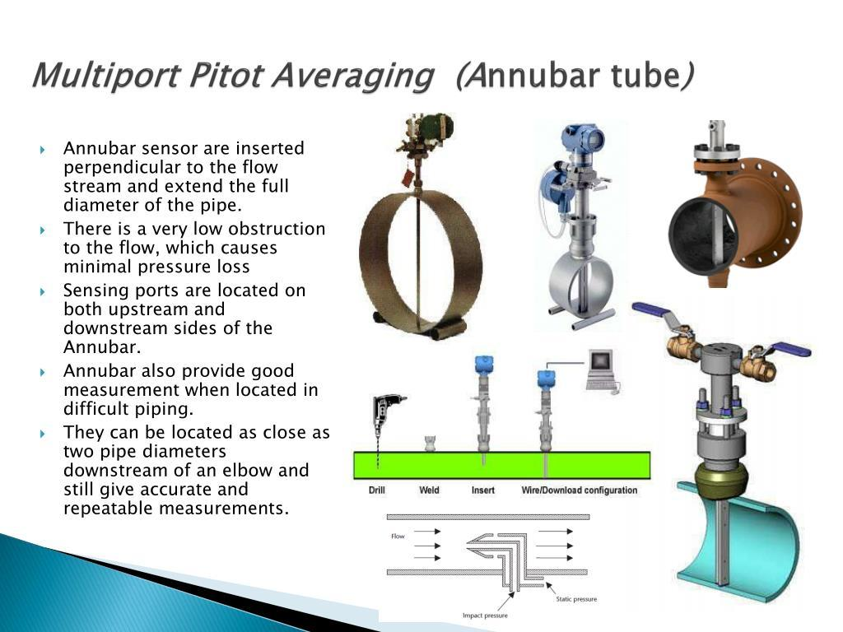
Description
Uses multiple sensing ports to provide an average velocity across a pipe.
Applications
- HVAC systems
- Large ducts
- Industrial pipelines

4. S-Type Pitot Tube
# Source: AI Source: Provided by: [Data Path: Persons Table -> ID Column: 1, Name_En Column: Motasem Essam] -> From: [ChatGPT] on [7/17/2026]
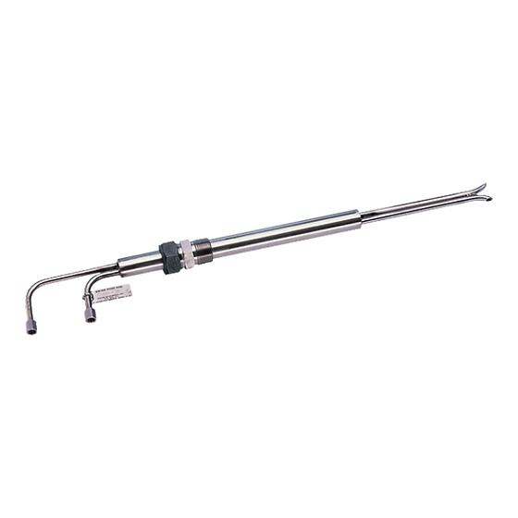
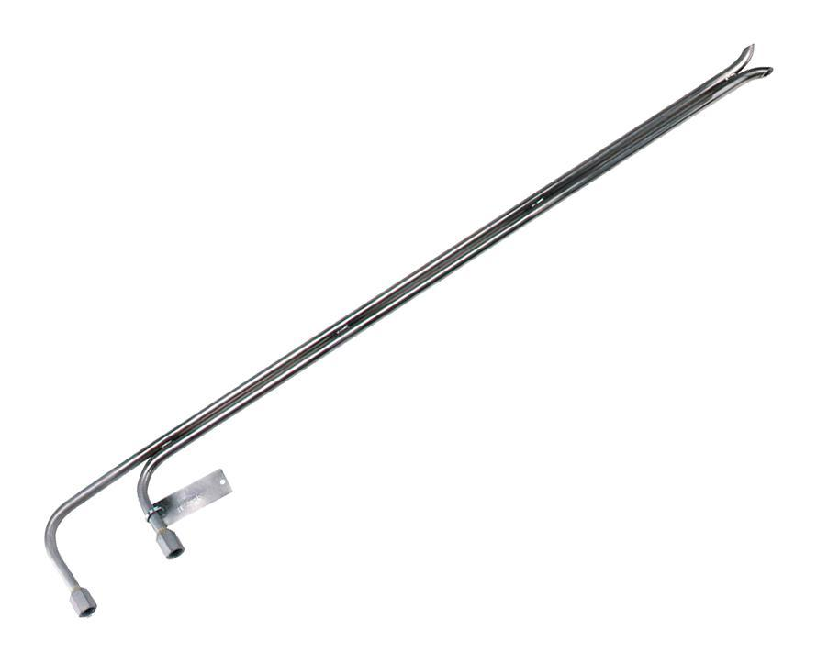
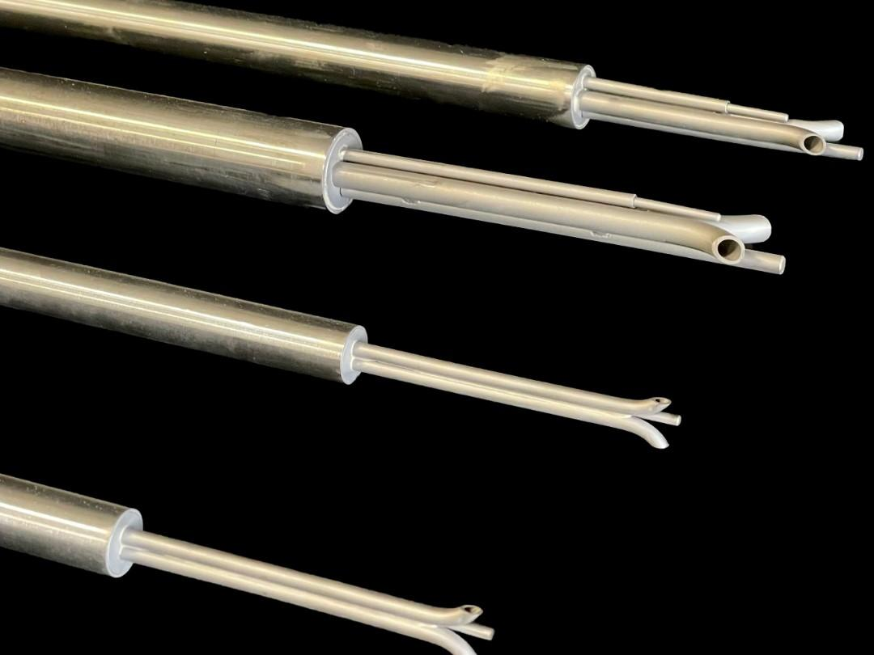
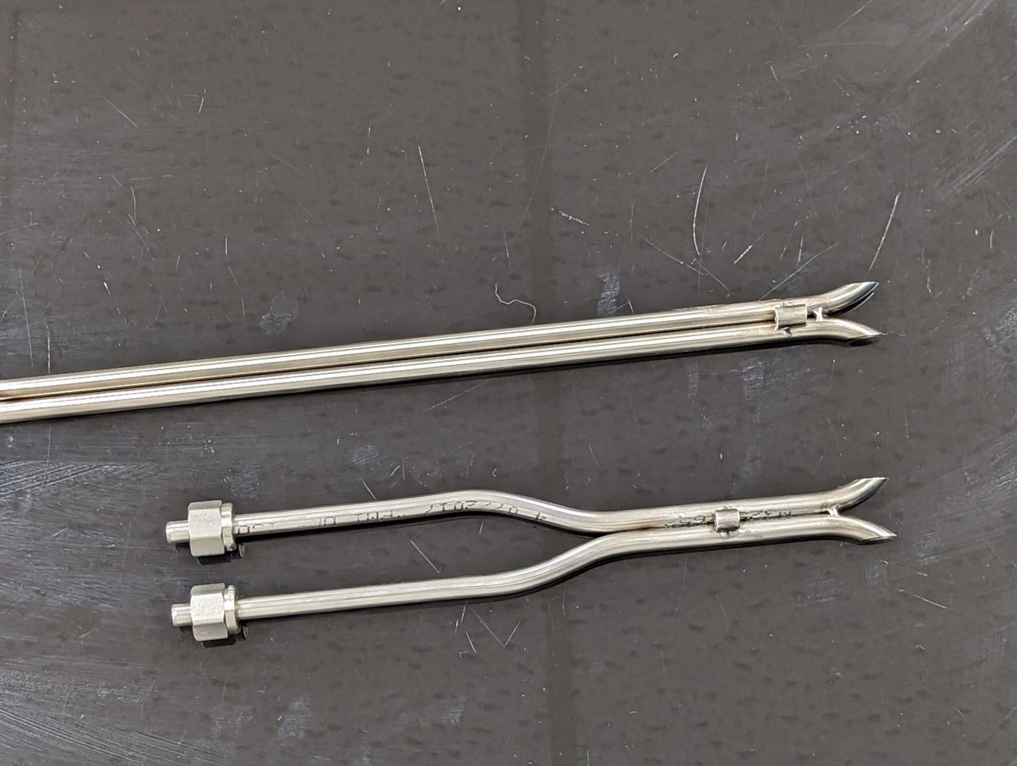
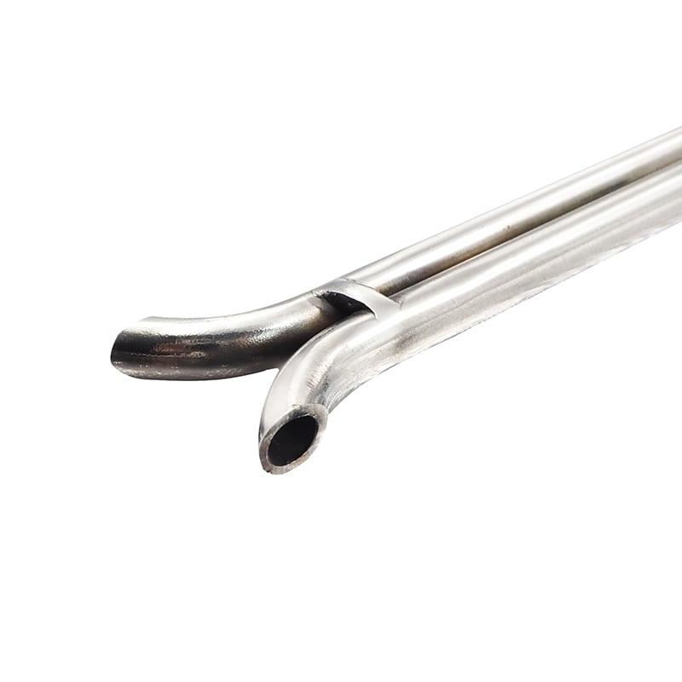
Description
Designed with two opposing openings to measure gas flow in ducts and exhaust stacks.
Applications
- Environmental monitoring
- Chimney emissions
- Industrial exhaust systems

Measuring Units
# Source: AI Source: Provided by: [Data Path: Persons Table -> ID Column: 1, Name_En Column: Motasem Essam] -> From: [ChatGPT] on [7/17/2026]
Pitot tubes measure velocity in:
- Meters per second (m/s)
- Kilometers per hour (km/h)
- Miles per hour (mph)
- Knots (kn)
- Feet per second (ft/s)

Measuring Range
# Source: AI Source: Provided by: [Data Path: Persons Table -> ID Column: 1, Name_En Column: Motasem Essam] -> From: [ChatGPT] on [7/17/2026]
The measuring range depends on the fluid and pressure sensor.
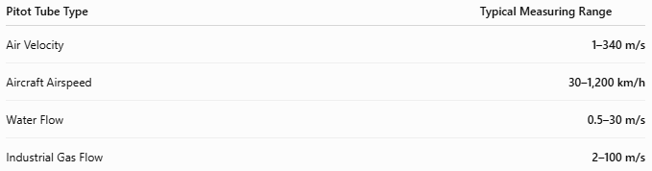
Pitot Tube Type | Typical Measuring Range
Air Velocity | 1–340 m/s
Aircraft Airspeed | 30–1,200 km/h
Water Flow | 0.5–30 m/s
Industrial Gas Flow | 2–100 m/s

Resolution
# Source: AI Source: Provided by: [Data Path: Persons Table -> ID Column: 1, Name_En Column: Motasem Essam] -> From: [ChatGPT] on [7/17/2026]
Resolution depends on the pressure measurement system connected to the Pitot tube.
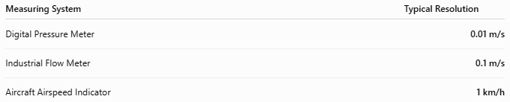
Measuring System | Typical Resolution
Digital Pressure Meter | 0.01 m/s
Industrial Flow Meter | 0.1 m/s
Aircraft Airspeed Indicator | 1 km/h

Accuracy
# Source: AI Source: Provided by: [Data Path: Persons Table -> ID Column: 1, Name_En Column: Motasem Essam] -> From: [ChatGPT] on [7/17/2026]

Pitot Tube System | Typical Accuracy
Laboratory Pitot Tube | ±0.5% of reading
Industrial Pitot Tube | ±1% of reading
Aircraft Pitot-Static System | ±1–2% of reading
Notes
- Accuracy depends on proper alignment with the flow direction.
- Clean pressure ports and calibrated pressure sensors improve measurement reliability.
- Turbulence and flow disturbances can reduce accuracy.

How to Use a Pitot Tube
# Source: AI Source: Provided by: [Data Path: Persons Table -> ID Column: 1, Name_En Column: Motasem Essam] -> From: [ChatGPT] on [7/17/2026]
- Insert the probe into the moving fluid.
- Align the Pitot opening directly into the flow.
- Measure the total and static pressures.
- Calculate the pressure difference.
- Convert the pressure difference into velocity using Bernoulli's equation.

Applications
# Source: AI Source: Provided by: [Data Path: Persons Table -> ID Column: 1, Name_En Column: Motasem Essam] -> From: [ChatGPT] on [7/17/2026]
Pitot tubes are used in:
- Aircraft airspeed measurement
- Wind tunnels
- HVAC systems
- Industrial pipelines
- Environmental monitoring
- Fluid mechanics laboratories
- Process engineering

Advantages
# Source: AI Source: Provided by: [Data Path: Persons Table -> ID Column: 1, Name_En Column: Motasem Essam] -> From: [ChatGPT] on [7/17/2026]
A Pitot tube:
- Provides accurate velocity measurements.
- Has a simple design.
- Causes very little flow obstruction.
- Can be used in gases and liquids.
- Requires minimal maintenance.

Limitations
# Source: AI Source: Provided by: [Data Path: Persons Table -> ID Column: 1, Name_En Column: Motasem Essam] -> From: [ChatGPT] on [7/17/2026]
A Pitot tube:
- Must be aligned with the flow.
- Cannot accurately measure very low flow velocities.
- Pressure ports can become blocked.
- Requires differential pressure measurement equipment.

Sources of Error
# Source: AI Source: Provided by: [Data Path: Persons Table -> ID Column: 1, Name_En Column: Motasem Essam] -> From: [ChatGPT] on [7/17/2026]
Instrument Errors
- Blocked pressure ports
- Calibration drift
- Damaged probe

User Errors
- Incorrect probe alignment
- Improper installation
- Reading errors

Environmental Errors
- Turbulent flow
- Air bubbles (liquids)
- Dirt or ice blockage (aircraft)
- Flow disturbances

Comparison with Other Speed Measuring Instruments
# Source: AI Source: Provided by: [Data Path: Persons Table -> ID Column: 1, Name_En Column: Motasem Essam] -> From: [ChatGPT] on [7/17/2026]
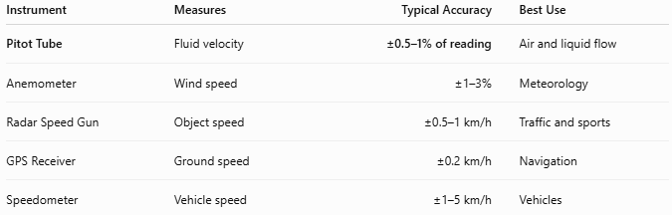
Instrument | Measures | Typical Accuracy | Best Use
Pitot Tube | Fluid velocity | ±0.5–1% of reading | Air and liquid flow
Anemometer | Wind speed | ±1–3% | Meteorology
Radar Speed Gun | Object speed | ±0.5–1 km/h | Traffic and sports
GPS Receiver | Ground speed | ±0.2 km/h | Navigation
Speedometer | Vehicle speed | ±1–5 km/h | Vehicles

Care and Maintenance
# Source: AI Source: Provided by: [Data Path: Persons Table -> ID Column: 1, Name_En Column: Motasem Essam] -> From: [ChatGPT] on [7/17/2026]
To maintain performance:
- Keep pressure openings clean.
- Inspect for damage or corrosion.
- Prevent blockage from dust, insects, or ice.
- Calibrate pressure sensors periodically.
- Store in a protective case.

Common Mistakes
# Source: AI Source: Provided by: [Data Path: Persons Table -> ID Column: 1, Name_En Column: Motasem Essam] -> From: [ChatGPT] on [7/17/2026]
- Incorrect alignment with the flow.
- Using a blocked Pitot opening.
- Ignoring turbulent flow effects.
- Failing to calibrate the pressure sensor.

Key Points
# Source: AI Source: Provided by: [Data Path: Persons Table -> ID Column: 1, Name_En Column: Motasem Essam] -> From: [ChatGPT] on [7/17/2026]
- A Pitot Tube measures fluid velocity, not solid object speed.
- It operates using Bernoulli's Principle by comparing total and static pressure.
- Common types:
  - Standard Pitot Tube
  - Pitot-Static Tube
  - Averaging Pitot Tube (Annubar)
  - S-Type Pitot Tube
- Widely used in aviation, HVAC, industrial flow measurement, environmental monitoring, and fluid mechanics.

Conclusion
# Source: AI Source: Provided by: [Data Path: Persons Table -> ID Column: 1, Name_En Column: Motasem Essam] -> From: [ChatGPT] on [7/17/2026]
A Pitot Tube is a simple yet highly effective instrument for measuring the velocity of moving fluids by comparing stagnation pressure and static pressure. Thanks to its accuracy, low flow disturbance, and reliable performance, it is widely used in aircraft airspeed systems, industrial flow monitoring, HVAC applications, environmental testing, and aerodynamic research.

